1:The IP address of my computer is 192.168.1.46.

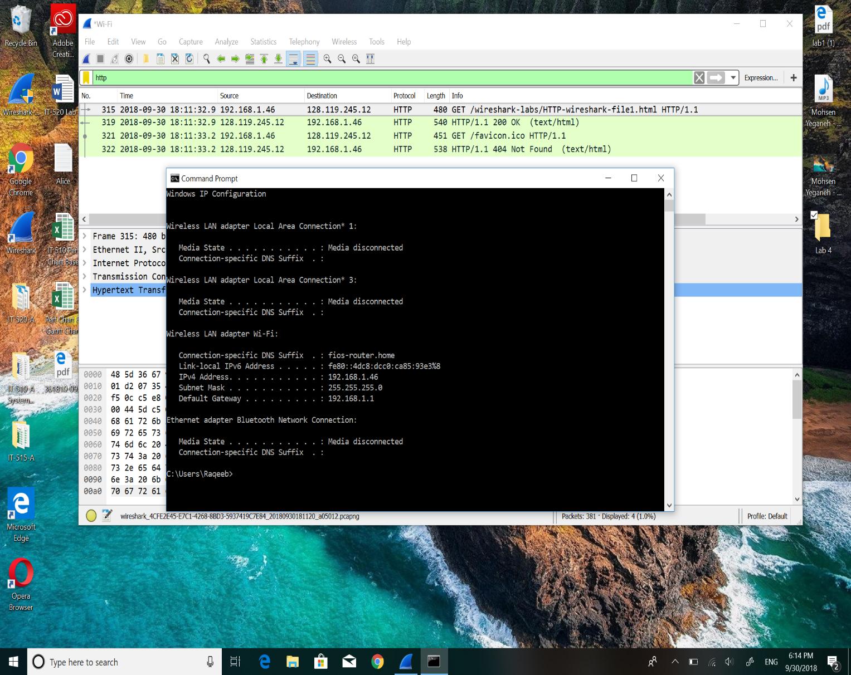



2: The total length of datagram is 466.

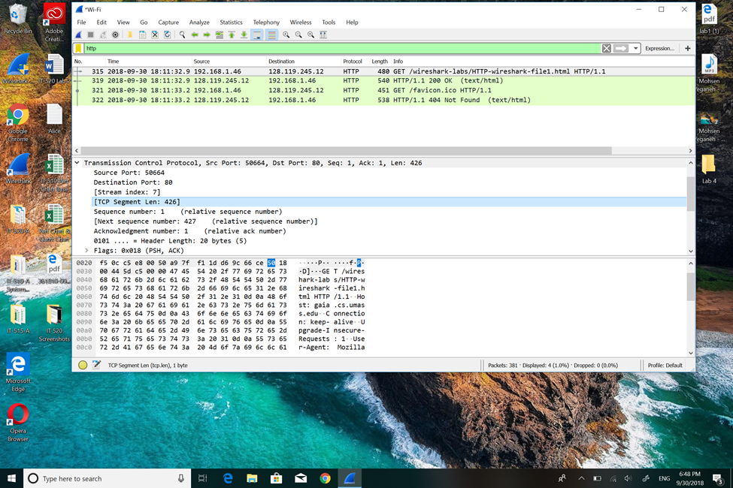



3: The IP address hasn’t been fragmented.

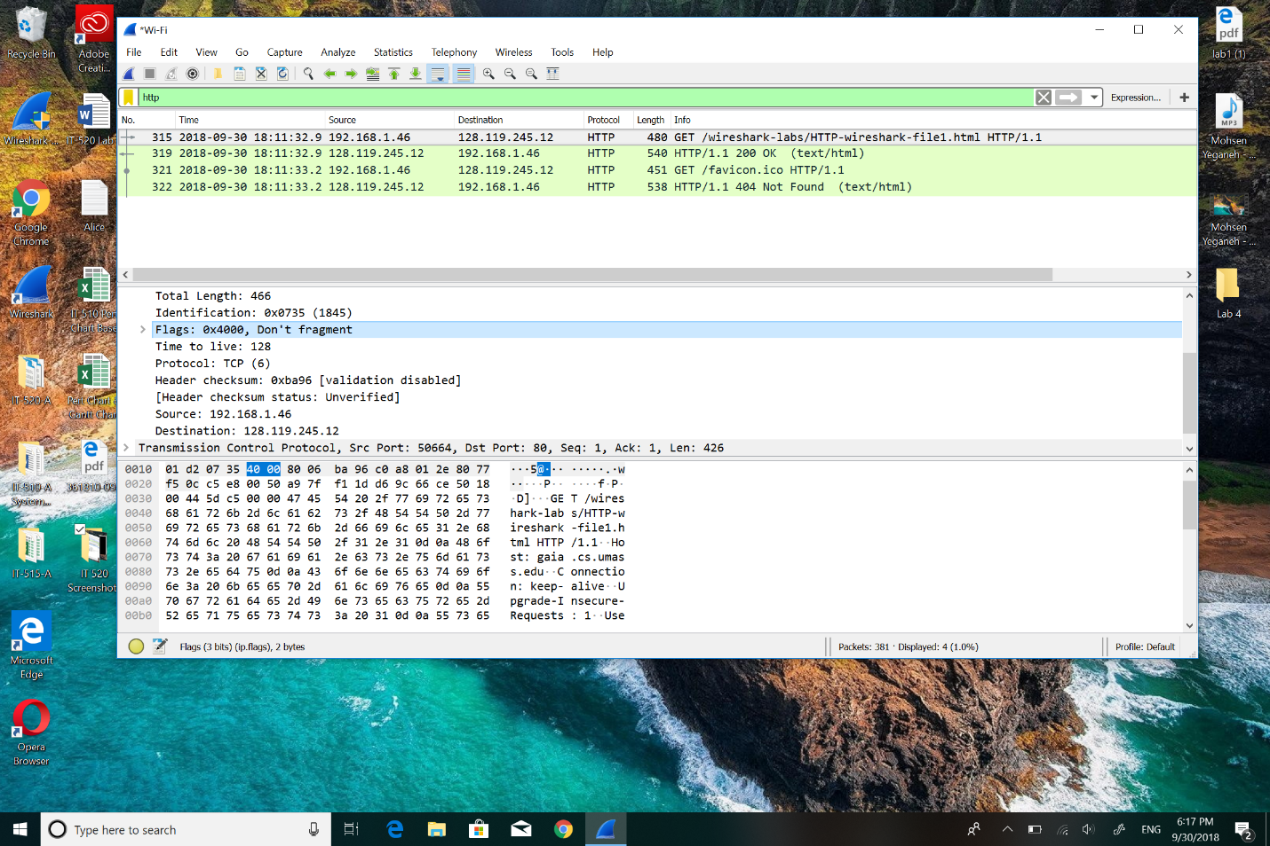



4: There are 20 bytes in the IP header.

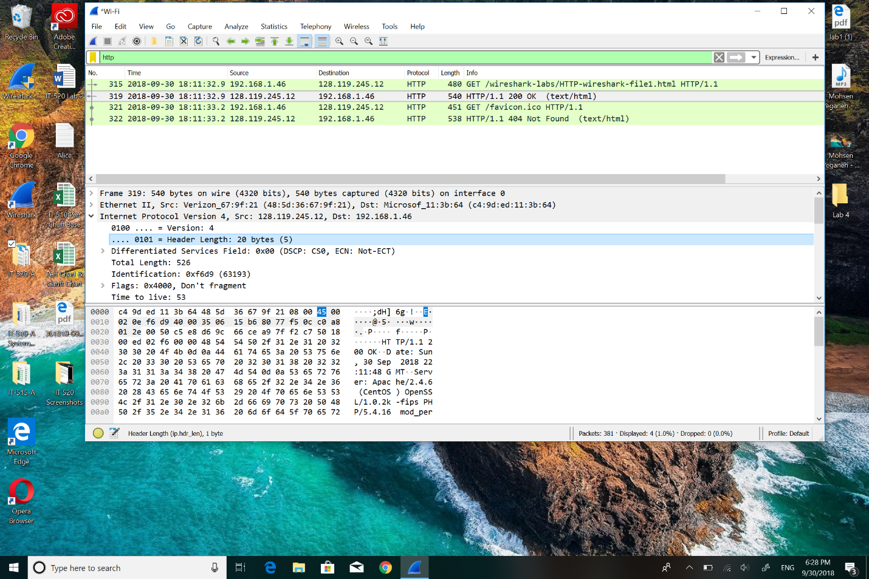



5: There are 406 bytes in the payload of IP datagram, and how it’s been determined is: to subtract the size of header which is 20 bytes here from the total payload to get the IP datagram bytes.

